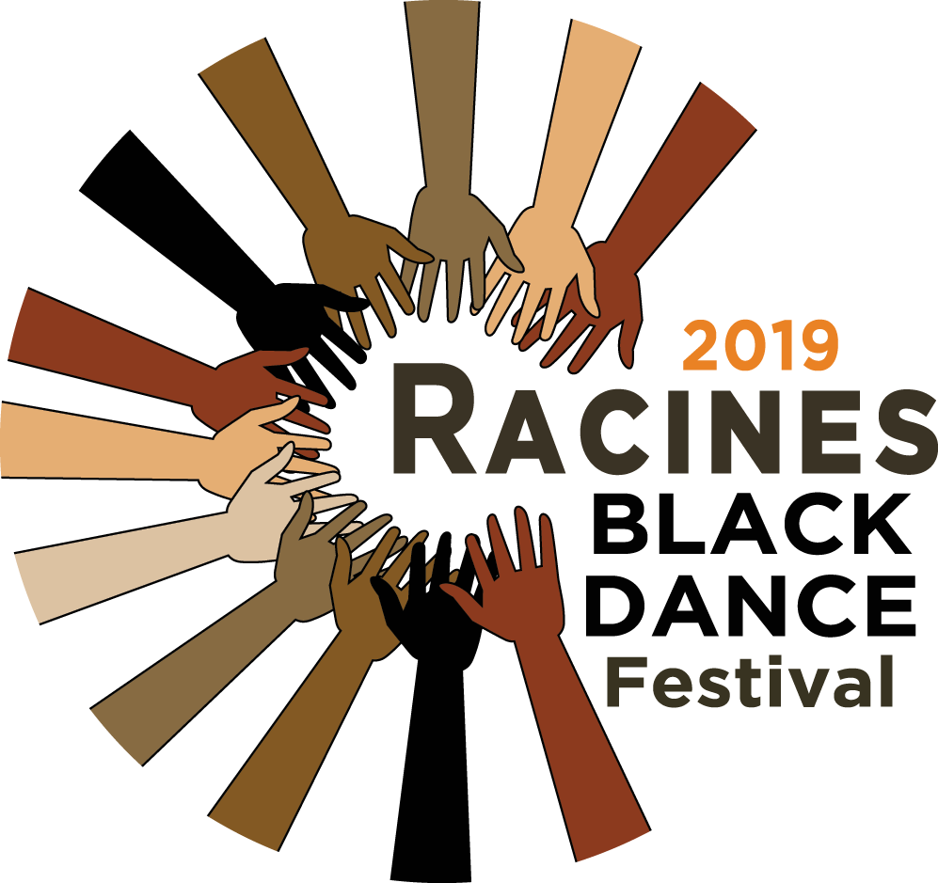

October 18-20, 2019. 10:00am – 8:30pm.
Boston Conservatory at Berklee
Mainstage Theater at RCC
Boston, MA

Please consider sponsoring the 3rd Annual Racines Black Dance Festival or purchasing an ad for the program book.
Sponsorship Opportunities

$5,000 | LEADER – 10 tickets to performance, 10 tickets to panel presentation; name listed in event signage, newsletter and program book; inside cover or back page ad in program book.
$2,000 | ORGANIZER – 8 tickets to performance, 8 tickets to panel presentation; name listed in event signage, newsletter and program book; includes full-page ad in program book.
$1,500 | ACTIVIST – 4 tickets to performance, 4 tickets to panel presentation; name listed in event signage, newsletter and program book; includes half-page ad in program book.
$1,000 | ALLY – 2 tickets to performance, 2 tickets to panel presentation name listed in event signage, newsletter and program book; includes quarter-page ad in program book
$500 | ADVOCATE – name listed in event signage, newsletter and program book; includes quarter-page ad in program book
$250 | FRIEND – name listed in event signage, newsletter and program book; includes eighth-page ad in program book
Program Book Advertisements

$2,000 | Full-page Ad
$1,500 | Half-page Ad
$500 | Quarter-page Ad
$250 | Eighth-page Ad
To sponsor the 2019 Racines Black Dance Festival or purchase an ad, please complete the attached form or contact Baindu Conté-Coomber at (415) 529-0198 or
sponsor@racinesfestival.org.
Racines is a fiscally sponsored project of JAARA, INC a 501(3) Non-profit.

3rd Annual Racines Black Dance Festival
October 18-20, 2019. 10:00am – 8:30pm.
Boston Conservatory at Berklee
Mainstage Theater at RCC
Boston, MA

I wish to become a sponsor and/or purchase an ad for the 2019 Racines Black Dance Festival

Name(s):

Sponsorship/Ticket Program Book Ads

□ $5,000 | Leader | □ $5,000 | Full-page Inside cover
□ $2,000 | Organizer | □ $2,000 | Full-page Ad
□ $1,500 | Activist | □ $1,500 | Half-page Ad
□ $1000 | Ally | □ $500 | Quarter-page Ad
□ $500 | Advocate | □ $250 | Eighth-page Ad
□ $250 | Friend | *All ads must be print-ready* (high resolution, 300+ dpi preferred)

ADDRESS:

CITY:
STATE:
ZIP:

EMAIL: PHONE:

ELECTRONIC PAYMENT CAN BE MADE VIA PAYPAL TO racines@jaara.org
CHECKS: Checks should be made payable to “JAARA – 2019 RACINES” and mailed to:
JAARA- 2019 RACINES
c/o Baindu Conté-Coomber
174 Sherrin Street
Boston, MA 02136

Deadline:
October 4th, 2019 Sponsorship and advertisement deadline for inclusion in the program book

Please email this form and desired art work to: sponsor@racinesfestival.org
All ads must be print ready (high resolution, 300+ dpi)

Questions? Contact Baindu Conté-Coomber at (415) 529-0198) sponsor@racinesfestival.org
Please note: Racines is a fiscally sponsored project of JAARA, INC a 501(3) Non-profit.

